**Sneha Adhikari**

BSc. (Hons.) Computing, Softwarica College of IT & E-Commerce, CoventryUniversity

ST6012CEM User Experience Design

Pratik Bhusal

May 31, 2024

Table of Contents

Introduction 4

Literature Review 5

Vogue Advertising and Event Management 5

WedTayari - Online Nepali Wedding Planning Site 6

User Feedback: Error! Bookmark not defined.

Summary of Low Fidelity Prototype: Error! Bookmark not defined.

Challenges and Solutions of Eventify Error! Bookmark not defined.

1. User Engagement and Feedback: Error! Bookmark not defined.

2. Navigation and Interface Complexity: Error! Bookmark not defined.

3. Error Handling and User Confusion: Error! Bookmark not defined.

4. Technical Limitations of the Prototype: Error! Bookmark not defined.

High Fidelity Prototype 7

High Fidelity Testing 8

User Feedback for High Fidelity Prototyping Error! Bookmark not defined.

Guerrilla usability testing 8

Conclusion 21

# **Table of Figures**

# **Introduction**

In today's dynamic event management market, the capacity to plan and participate in gatherings that provide memorable experiences and achieve desired outcomes is critical. With an expanding number of events and more discerning participants, event planners confront the difficulty of maximizing resources while constantly adapting to changing participant expectations. Traditional, inflexible approaches to resource management are no longer sufficient in today's fast changing world, forcing a transition to more flexible and participative methodologies.

Eventify allows customers to easily purchase event tickets, create their own events, and book locations. This combination of methods empowers organizers and participants by providing powerful tools to improve their event experiences. Eventify is a simplified platform designed to meet a variety of organizing needs, including purchasing tickets for forthcoming events, planning personalized gatherings, and securing perfect venues. By combining these features, Eventify not only simplifies the event planning process, but also encourages better engagement and efficiency among the event management community. This user-centric approach ensures that users can easily traverse the complexity of event logistics, making Eventify an important tool for defining the future of event organization and participation. Eventify addresses the inherent issues of modern event management with its adaptable design and adaptive features, including real-time updates, tailored experiences, and dynamic feedback systems. The application's commitment to remaining current with industry trends means that users may employ the most recent advancements to produce impactful and memorable events.

Eventify, as a change agent in the industry, not only redefines event planning but also improves the complete event experience for stakeholders. Eventify raises the bar for event management solutions by encouraging agility, creativity, and strategic adaptation, with the potential to change the future of global meetings and celebrations.

# **Literature Review**

## **Vogue Advertising and Event Management**

The effectiveness of advertising and event management campaigns heavily relies on design, as it serves as the bridge connecting businesses and their target consumers. Vogue Advertising and Event Management, with its dedication to innovation and improvement, recognizes the importance of design, particularly in the areas of User Interface (UI) and User Experience. In today's world, UI/UX design goes beyond aesthetics; it focuses on crafting smooth, user-friendly experiences that connect with people.

Good user interface design is based on keeping things simple and easily understood. By simplifying interfaces and focusing on essential features, Vogue Nepal can ensure that users can effortlessly navigate their digital campaigns. This focus on simplicity also goes to making sure that design elements are the same on all devices. By maintaining the same approach to branding and visual design, Vogue Nepal can enhance its identity and build trust among its audience.

Another important feature of UI/UX design is responsiveness. Given the growing number of mobile devices, it is crucial for interfaces to perfectly adjust to different screen sizes and orientations. By using responsive design, Vogue Nepal can ensure that its digital content is accessible and usable on a wide range of devices, hence improving user experience.

Vogue Nepal could enhance user engagement by combining UX design techniques with UI design principles. Vogue Nepal's user-centered design, which is based on extensive research and testing, enables it to customize its services to the specific requirements and tastes of its target audience. This approach guarantees that digital campaigns and event management systems are not only visually attractive, but also useful and beneficial for users.

Considering accessibility is crucial in UX design. Vogue Nepal can make its content more inclusive and accessible to all users by incorporating disability-friendly features, such as providing alt text for photographs and enabling keyboard navigation. In addition, user-friendly navigation and engaging interactions play a crucial role in creating a satisfying experience for users, making it easier for them to interact seamlessly.

Vogue Nepal sets a new standard for advertising and event management by seamlessly integrating UI/UX design concepts into its solutions. Vogue Nepal expands its product and service offerings while maintaining market leadership via continual innovation and user-centered design. By being at the forefront of the competitive market, Vogue Nepal inspires others to follow suit by providing superior advertising and event management solutions. This is only possible because of our unwavering dedication to achieving the highest standards. Vogue Nepal prioritizes creating an entire client as well as public experience, focusing on smoothly integrating these concepts to promote trust and long-term collaboration.

To summarize, effective advertising and event management require excellent UI/UX design. By prioritizing simplicity, consistency, responsiveness, and a user-centric approach, Vogue Nepal can create captivating experiences that captivate and involve its audience. Vogue Nepal has an opportunity to further push the boundaries of the industry through strategic design efforts and a strong dedication to quality.

## **WedTayari - Online Nepali Wedding Planning Site**

WedTayari, an online Nepali wedding planning platform, is gaining attention in the wedding preparation industry due to its focus on user needs and modern design. This platform is an ideal example of design innovation that is changing the wedding planning industry. On its website, WedTayari.com provides a smooth and effortless user experience, simplifying the process of wedding preparation. The key to WedTayari's success is its dedication to reducing the stress of wedding planning with careful attention to detail. The website offers individuals a range of resources and advice that meet their particular needs, enhancing the comfort of the planning process with its user-friendly layout. With its budget calculators and vendor listings, WedTayari gives couples all the tools they need to confidently plan their dream wedding. WedTayari's approach to design prioritizes accessibility and inclusiveness. WedTayari takes great care in selecting vendors that respond to the unique preferences and requirements of Nepali couples. WedTayari connects users with experienced professionals in various wedding-related fields to ensure easy wedding planning in every detail. In order to create a sense of community and connection among users, WedTayari's design goes beyond traditional functionality. WedTayari dedicates itself to showcasing and honoring the beautiful love stories and rich cultural traditions of marriage. It carefully gathers a selection of articles, blog posts, and real wedding images to share and celebrate these unique stories. WedTayari encourages couples to openly share their thoughts and journeys in planning their wedding, creating a friendly and inclusive environment. WedTayari sets itself apart from other companies by providing outstanding customer service and personal attention. The vast network of wedding experts on the site is prepared to help individuals at any point in the organizing process, providing guidance and support to guarantee a flawless and unforgettable event. WedTayari improves service quality and builds trust in individuals as they manage the complexity of wedding preparation by focusing on personalized attention and timely replies. WedTayari, therefore, demonstrates the influence of outstanding UI/UX design on the wedding planning process. WedTayari provides a complete solution that effortlessly combines cutting-edge technology, personal help, and a deep knowledge of Nepali wedding traditions. This innovative approach completely transforms the entire wedding preparation process. WedTayari guarantees that each wedding is a delightful and unforgettable occasion, blending innovative design with an unwavering dedication to excellence.

# **Product Development:**

## **Low Fidelity:**

While conducting low fidelity prototype testing of the Eventify app, the Wizard of Oz technique identified certain essential parts that require development. Users found major navigation and interface difficulties, with challenges listing or searching for events due to the initial design's lack of clear direction. In order to tackle this issue, the interface was simplified by removing unnecessary procedures and integrating clearer visual clues and instructions. Engaging non-digital clients became tough because they struggled to express their opinions. This issue was addressed by utilizing simple language and realistic examples to effectively gather user response. Additionally, error handling and user misunderstandings were common, with users regularly submitting incorrect information or misinterpreting abilities. To address this, clear error messages and solutions were included to help users rapidly resolve issues. The prototype's technical limitations were also acknowledged, especially that it was unable to replicate changing relationships and handle real-time data. In testing, interactive scenarios and role-playing were implemented in order to better replicate the user's experience and get accurate feedback.

## **Implemented Improvements:**

The majority of UI-related components stayed unchanged due to the favorable reviews they received. However, the comparison functionality received adjustment to reduce its length, with

additional reduction expected for future development. The system status issues identified during testing were effectively addressed by implementing more frequent success alerts and displaying visible progress. The problem with the verification code during password changes has been resolved, hence improving security. To make up for the initial obstacle caused by the unappealing appearance of the paper prototype, attempts were made to provide a visually appealing and clear user interface. In conclusion, these improvements were implemented to increase the ease of use, user interaction, error management, and visually appealing design, resulting in a more intuitive and user-friendly experience.

# **High Fidelity Prototype**

High fidelity prototype is the process of developing detailed and interactive models of a product that closely mimic its final design in terms of functionality, look, and user experience. These prototypes frequently incorporate realistic graphics, sophisticated interactions, and extensive functionality, giving a clear and accurate depiction of the final product. High-fidelity prototypes are used to test and validate design decisions, collect user feedback, and make final changes prior to development. They help stakeholders understand how the completed product will look and function, allowing any issues to be identified and addressed early in the design process.

# **Guerrilla usability testing**

Guerrilla testing is a type of usability testing that enables researchers to collect user feedback in public areas. The application of this strategy is defined by its high efficiency and cost-effectiveness. To evaluate the design and functionality of a product, they interact with a random group of individuals, generally for a small price, in order to collect feedback. It will enable them to evaluate the product. This approach does not require using of formal testing settings in order to accomplish the objective of collecting genuine and unique feedback from users.

# **High Fidelity Testing**

* **Visibility of System Status:** Eventify ensures that its consumers are constantly updated about their actions by offering a variety of feedback choices, such as status signals and alarms. Maintaining awareness of the current condition of their actions is important for avoiding future challenges and minimizing confusion about what will happen. This action is made to maintain a sense of assurance.
* **Example:** When users book an event, a confirmation message shows in real time, indicating that the action was completed.

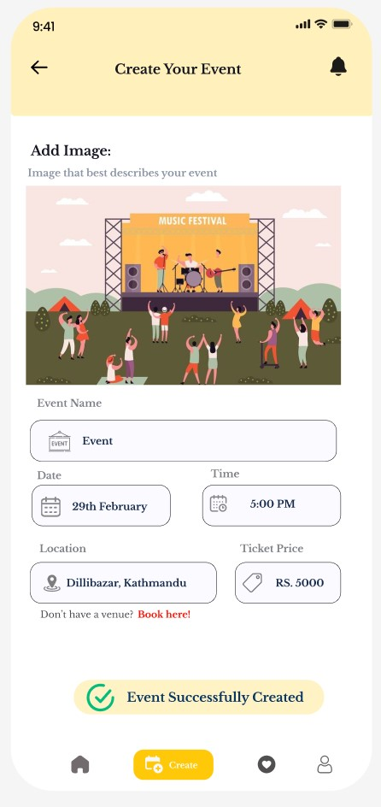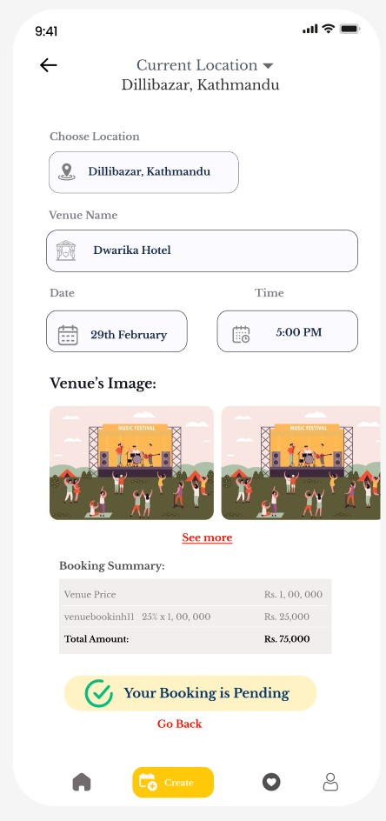

1. **Match Between System and the Real World:** The app makes use of well-known iconography and terminology that is derived from true life scenarios, which promotes user understanding and makes management more simple. When one maintains up to date on the standards used in the actual world, the learning process becomes simpler and easier to understand.

* **Example:** The event and ticket icons are put together so they resemble real event tickets and calendar symbols that users are already familiar with.

1. **User Control and Freedom:** Eventify offers a wide variety of tools which includes confirmation dialogs and back buttons. With these tools, people can change or undo actions that have already taken place. User might utilize these functionalities to return to earlier activities and adjust them. As a result, users have more flexibility of choice, even if there are more alternatives for reversing or repeating tasks.

* **Example:** Users receive a confirmation dialog when attempting to delete their account, allowing them to fix any errors before the deletion happens.

1. **Consistency and Standards:** Using the same colors, fonts, and icons throughout all of the displays, this application ensures that each and every user will have the same experience. This is achieved through using the same features. When consistency is present, users are able to predict interactions and navigate the app without facing any confusion. This is because interactions are predictable.

* **Example:** The home, details, and booking screens follow a similar scheme of colors and font styles, which makes the user experience consistent.

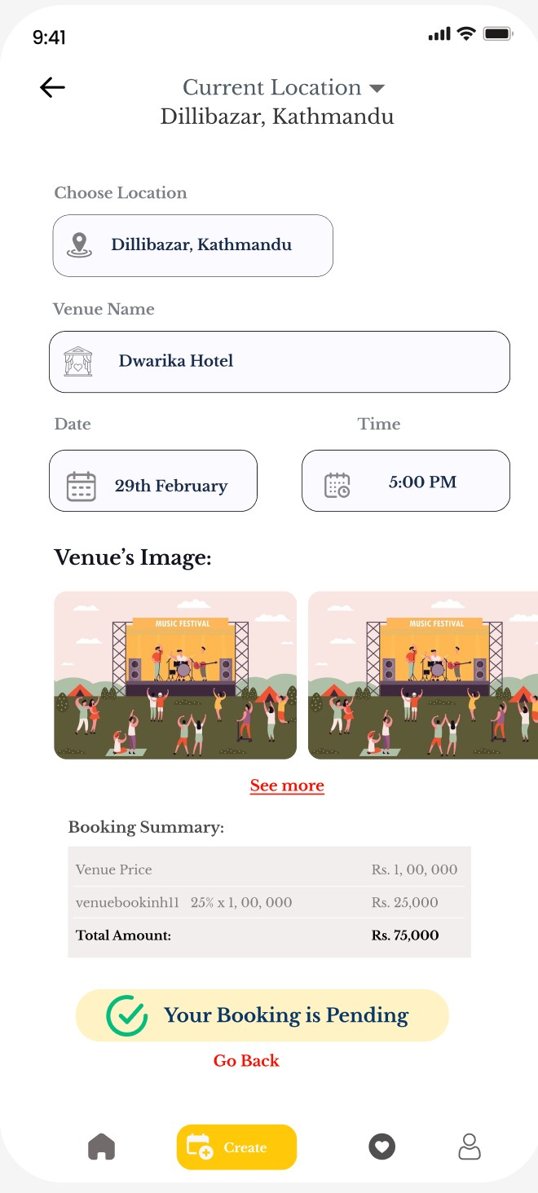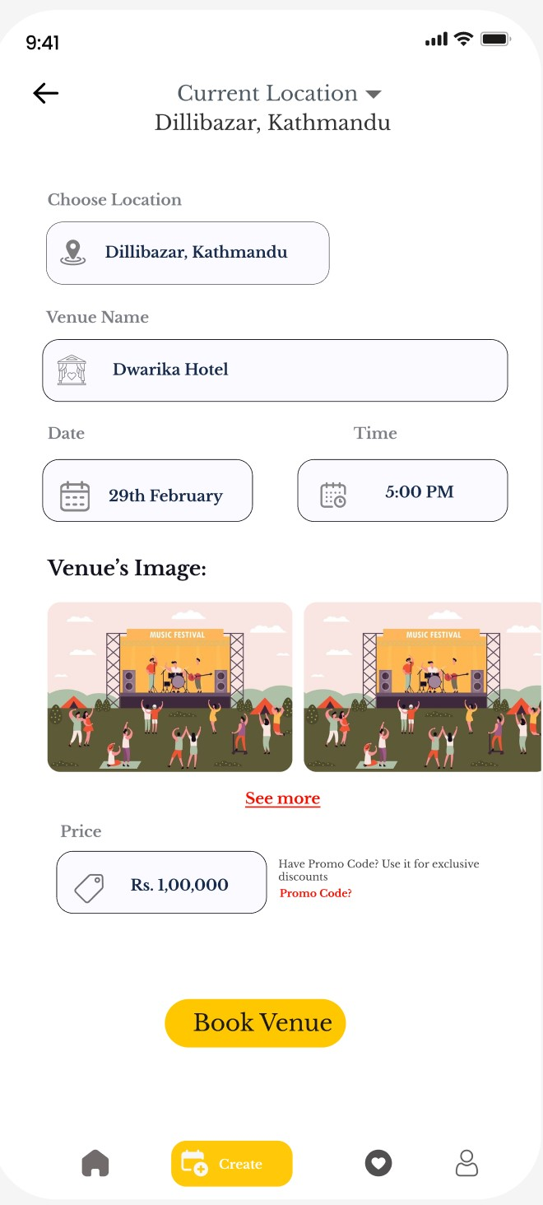

1. **Recognition Rather Than Recall:** As a result of the offering options and, where possible, pre-filling of user input, the amount of mental work required is decreased. This reduces the amount of mental effort that is necessary. It reduces any requirement for users to remember information from one action to the next, which is an important feature made possible by its implementation.

* **Example:** User information, including their name and address, is stored and automatically filled when making a booking, improving the process for repeated tasks.

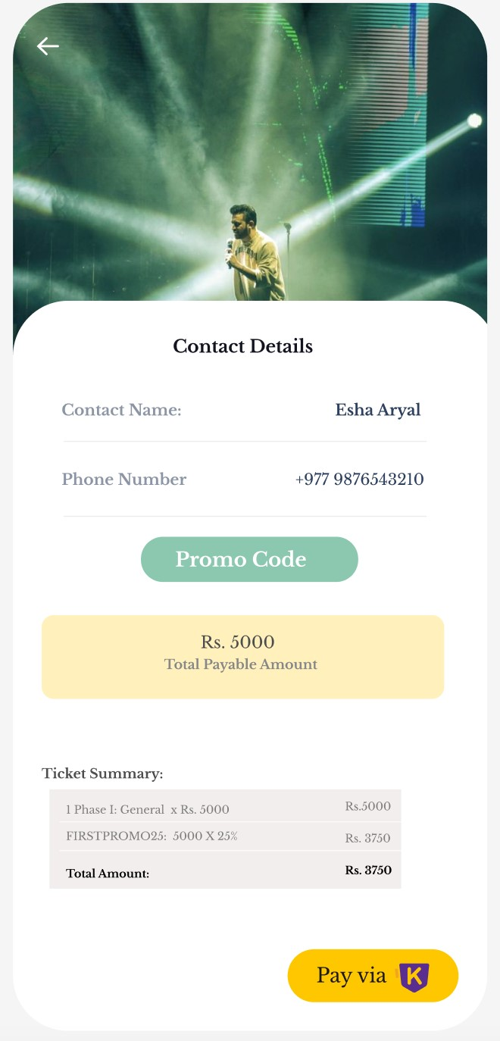

1. **Flexibility and Usability:** Eventify offers to both new and experienced users by including features that improve usability for everyone. This involves offering faster methods and detailed choices for those who have prior experience with the application, while still ensuring simplicity for new users.

* **Example:** The application provides easy access to favorite events and a good search feature, allowing easy navigation for users of different experience.

1. **Aesthetic and Minimalist Design:** To maintain an organized and simple design, Eventify focuses the most important components and excludes any features that are not absolutely necessary. This reduces users' mental stress, allowing them to focus on successfully performing activities.

* **Example:** The user interface is defined by a simple layout, presenting just the necessary details within an understandable way to avoid any possible errors.

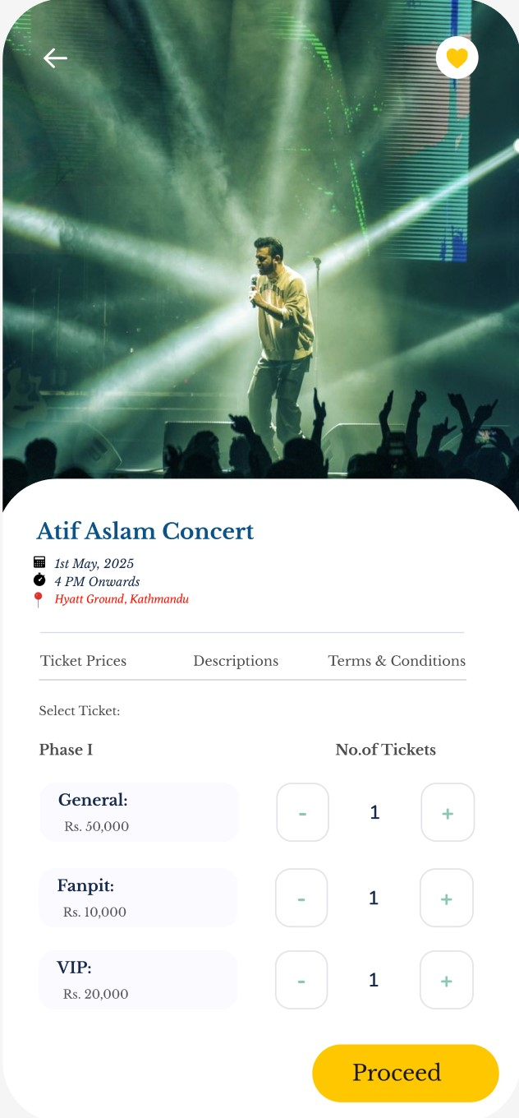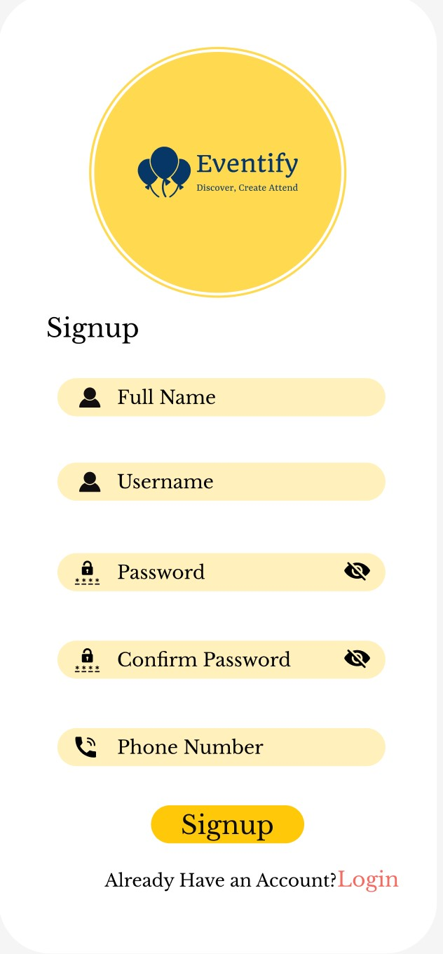

1. **Help Users Recognize, Diagnose, and Recover from Errors:** Pop-up notifications and messages within the application assist users in determining what went wrong and resolving the issue. On the other hand, it might be simpler if it provided error warnings that were more understandable and better instructions for fixing them.

* **Example:** If purchasing the ticket fails, a warning message pops up to tell users what to do next, though additional information might be helpful.

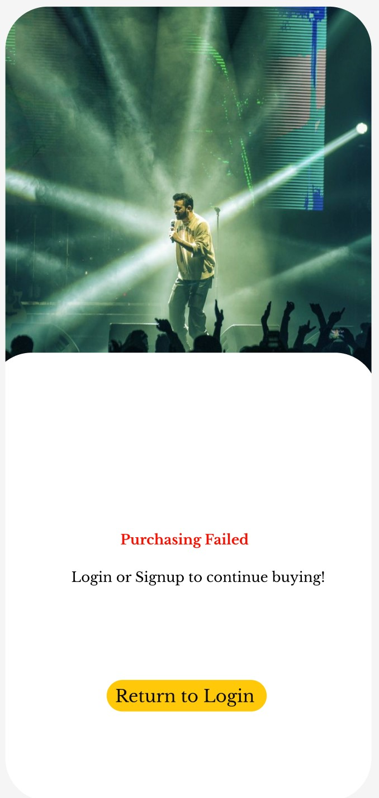

1. **Error Prevention:** Eventify offers error prevention methods such as confirmation messages and input validation to reduce the number of errors generated. This functionality allows users to take preventative measures to avoid problems in the first place.

* **Example:** Before logging out of the application, users are asked to confirm their actions, which reduces the possibility of accidental logouts.

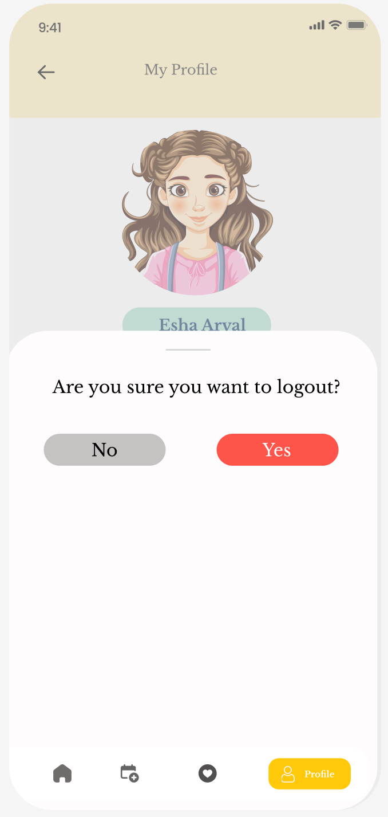

1. **Help and Documentation:** Not Used: Eventify doesn't have full in-app help and documentation yet; instead, it focuses on making the app easy to use and giving only basic instructions. Offering full support and full documentation may greatly help consumers in need of additional help.

* **Example:** The app's instructions aren't very clear. They should be improved by adding additional help features to make them easier for users to understand.

# **Final Product**

Eventify was developed as an individual project, employing a combined use of Flutter for the user interface and the MEN stack (MongoDB, Express, Node.js) for the server-side. This technological stack was chosen due to its adaptability, performance, and personal ability in developing a dynamic, mobile application. The front-end was designed with Flutter, creating a smooth and engaging user experience. Flutter was chosen because of its ability to generate natively built mobile, web, and desktop apps from a single codebase. The development of key elements, such as event management, ticket purchasing, and user profiles, prioritized usability. A combined and minimalist design was implemented according to flat design principles, resulting in a clear and simple user experience. The backend was constructed using Node.js and Express.js, providing an efficient and scalable framework for managing user requests and data processing. MongoDB has been used as the database for storing event information, user data, and other essential information. This combination allowed effective data administration and extraction, supporting the ever-changing nature of the application. Eventify was created utilizing a hybrid approach that combined the Waterfall and Scrum techniques to take on the advantages of each. The project started using the Waterfall technique, which established a strong base through initial research, collecting of needs, and planning. This thorough procedure ensured that the project's scope and goals were clearly specified. After the first foundation was set, the development process transitioned to Scrum, enabling a progressive and iterative approach to software development.

## **Metaphor in Design**

When it comes with design, metaphors serve as guiding lights, utilizing images and symbols that are already identifiable to users to facilitate easy navigation across interfaces. Universally accepted icons, such as a pencil for editing and a heart for the favorites, speed up user engagement by immediately expressing their functionalities. Because of this simplicity, user engagement is increased, and it is ensured that navigating through the program presents a sense of being basic and intuitive

**Strange Metaphor**

Consumers are drawn to a creative layout because it includes unexpected aspects. One of the most unexpected features is the integration of these elements. An example of this would be the discovery of previously undiscovered fortune within a town that is presently operating at full capacity to house its citizens. Creating a sense of surprise and excitement may be accomplished through many ways. One approach is to include funny visuals and memorable symbols in unexpected places. To achieve this goal, they might be put in unexpected locations. This not only makes it easier for the user to participate in the event, but it also increases their chances of having an enjoyable experience.

**Visual Perception**

The clarity of design is like trails, which have distinct visual signals and qualities that remain consistent throughout the route, just as paths in a park are easily identifiable. Users gain a sense of intelligence and power because of the introduction of different feedback signals indicating completed tasks. Color coding and progress indicators have significantly simplified the navigation process, and their presence confirms action completion.

**Emotional Design**

Designing comfortable and enjoyable experiences is like carefully constructing a welcoming home where every element enhances a feeling of comfort and satisfaction. The combination of peaceful colors, relaxing motion graphics, and well-chosen fonts effectively create positive sentiments and increase user involvement. By successfully incorporating these aspects, designers not only guarantee visual attractiveness but also provide an environment that promotes user comfort and connection. This purposeful strategy promotes a long-lasting impact, motivating people to engage with assurance and gain authentic enjoyment from their digital experiences.

## **Flat Design**

The concept of simplicity in design can be compared to the comfort of a peaceful and balanced environment, where every element serves its purpose without overpowering the senses. Designers enhance user navigation through using two-dimensional designs and incorporating user-friendly interfaces. This approach not only decreases confusion but also enhances user-friendliness by prioritizing crucial tasks and reducing interruptions. Like a carefully designed garden path, these designs emphasize simplicity, enabling users to focus on their tasks with clarity and efficiency, resulting in a smooth and enjoyable user experience.

## **Rules of Closure (Gestalt Law)**

The law of closure states that humans mentally complete incomplete forms, making them look full. In design, this idea is used to produce consistent visual components, such as rounded-corner buttons or tightly grouping content blocks to indicate a singleness. This improves users' ability to comprehend information naturally and use interfaces more easily. For example, in the design of comparison data analysis and search results, visual grouping helps people absorb and process information more rapidly.

**Gimmicks**

Gimmicks in design play an important role in increasing user engagement by including entertaining and surprising aspects that enhance the user experience while keeping functional fidelity. In Eventify, these design components are carefully used to respond playfully to user inputs, resulting in a more engaging engagement. For example, using animations during transitions between different comparison components adds a dimension of enjoyment, making the navigation process not only functional but also interesting and memorable.

These interactive features considerably improve the overall usability of the application, resulting in a more dynamic and entertaining user experience. By incorporating such amusing features, Eventify not only meets functional needs but also exceeds them by providing customers with moments of delight and surprise. This strategy not only improves user happiness but also increases the app's appeal, ensuring that users have a great and memorable experience when using the platform for event planning and management. **Activity Theory**

Activity theory in design is associated with understanding users' goals and processes inside a system. For addressing the various needs & situations of users, features such as task management tools, customized suggestions, and adjustable preferences have been developed to cater diverse user needs and contexts. This technique guarantees that users may accomplish their goals quickly and effectively with the system's assistance. Improved usability is achieved through features such as search filters and customized choices that serve to users of all levels.

## **6:3:1**

The 6:3:1 principle stresses a distinct visual hierarchy in which primary activities (6) are widely presented, secondary actions (3) are accessible but less visible, and tertiary actions (1) are reduced. The concept had been implemented throughout the project by prioritizing important elements such as search and navigation on the user interface and placing less often used capabilities in secondary menus or contextual choices. Key navigation buttons like "Home," "Create Event," "Favorites," and "Book Venues" are clearly visible, allowing for natural and easy user interaction.

**Golden Path**

The term "golden path" refers to an ideal user experience that is simple, effective, and transparent. Throughout the project, the golden road concept was successfully executed by ensuring that navigation lanes were clear, and transitions were smooth. When proper procedures, such as task completion and registration, are followed, users can achieve their goals with minimal effort and maximum satisfaction. This is made feasible by the implementation of proper processes.

# **Conclusion**

# Eventify is constantly improving its capabilities to meet the constantly evolving event management needs. This is performed by seeking user feedback and conducting guerrilla tests. This continuous method not only provides users with an enjoyable experience at all times, but it also enhances the app's usability and overall efficiency.Its goal is to address the demand for event planning solutions that are both flexible and simple to use. Eventify has developed an effective user interface and unique design concepts that help in the event management process. This allows the organizers and participants to have a clear and satisfying experience. The high-fidelity prototype evaluated using Nielsen's 10 heuristic principles shows that Eventify emphasizes visibility, real-world consistency, user control, error prevention, and simple design. The prototype has been evaluated, which clearly demonstrates this. Despite the need for further improvement in terms of additional assistance and documentation, the app's overall design greatly enhances its usability and effectiveness.

# Eventify has considerably enhanced its functionality by combining redesigns and feedback from clients to better meet the ever-changing needs of event management. This was done to guarantee high levels of satisfaction. The developers employ guerilla testing to ensure that the event planning tool is constantly improved based on real-world customer feedback. The ultimate product is a user interface that is both functional and minimal.

# **Appendix**

**User Persona and Consent Form**

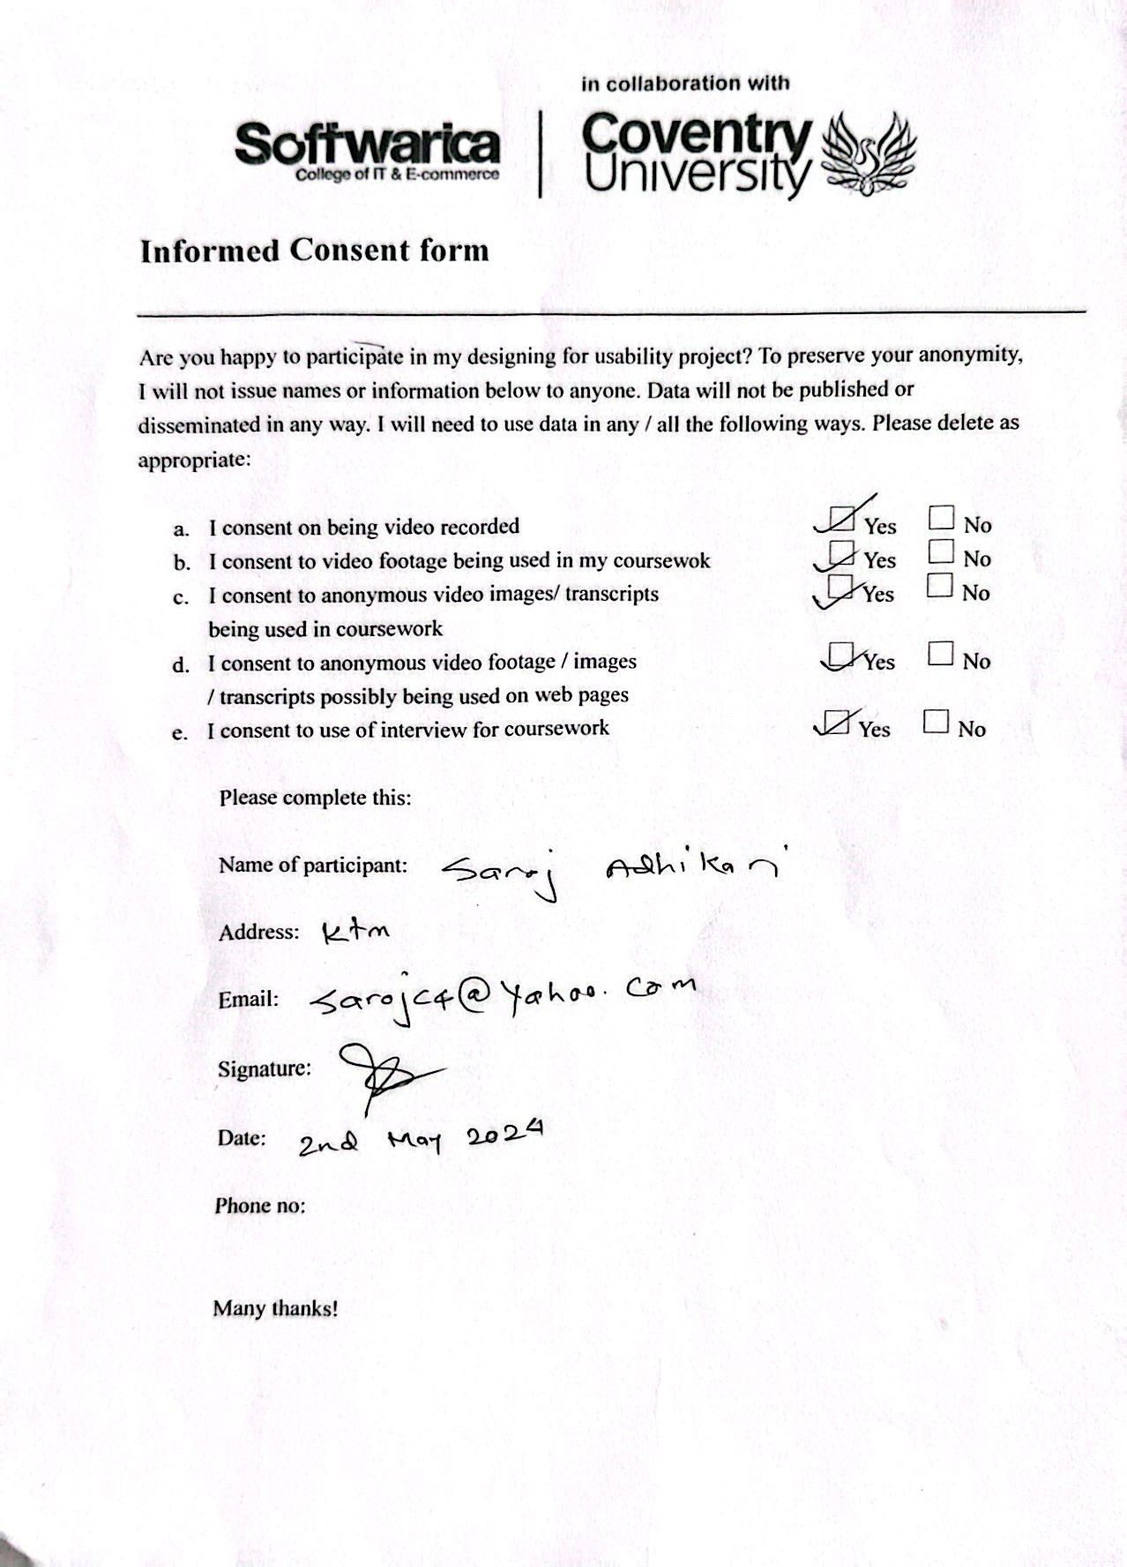

Figure 1: Conset form 2

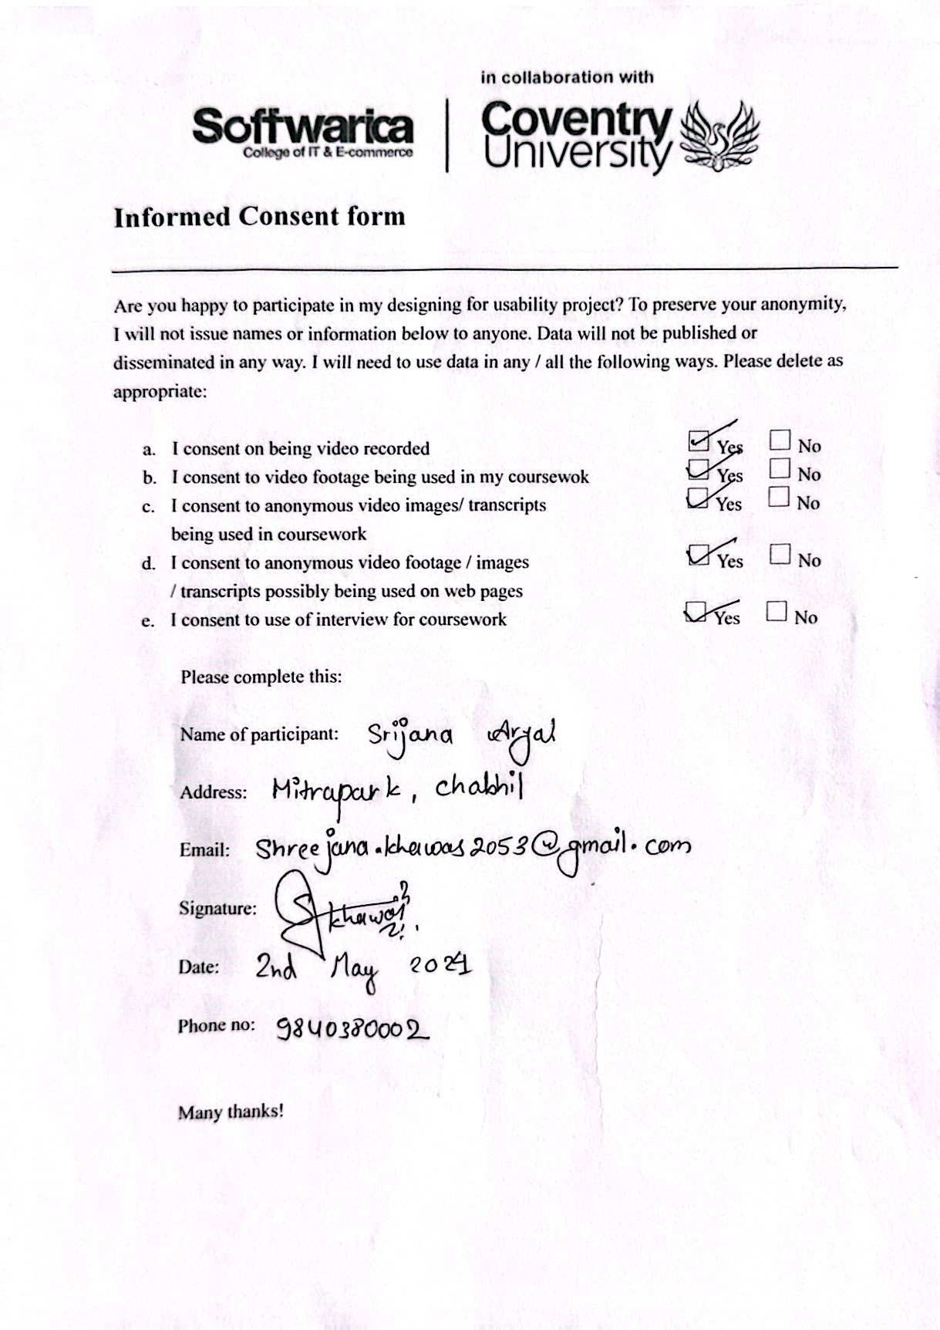

Figure 2: Consent For 3

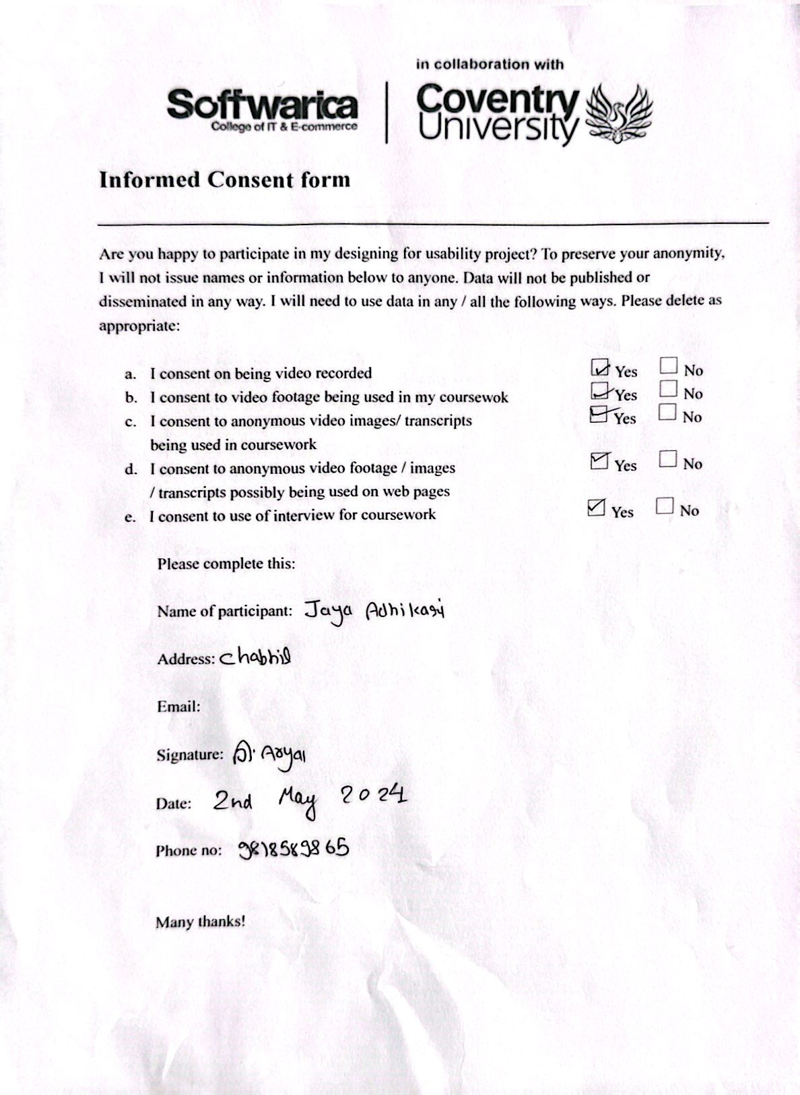

Figure 3: Consent Form 4

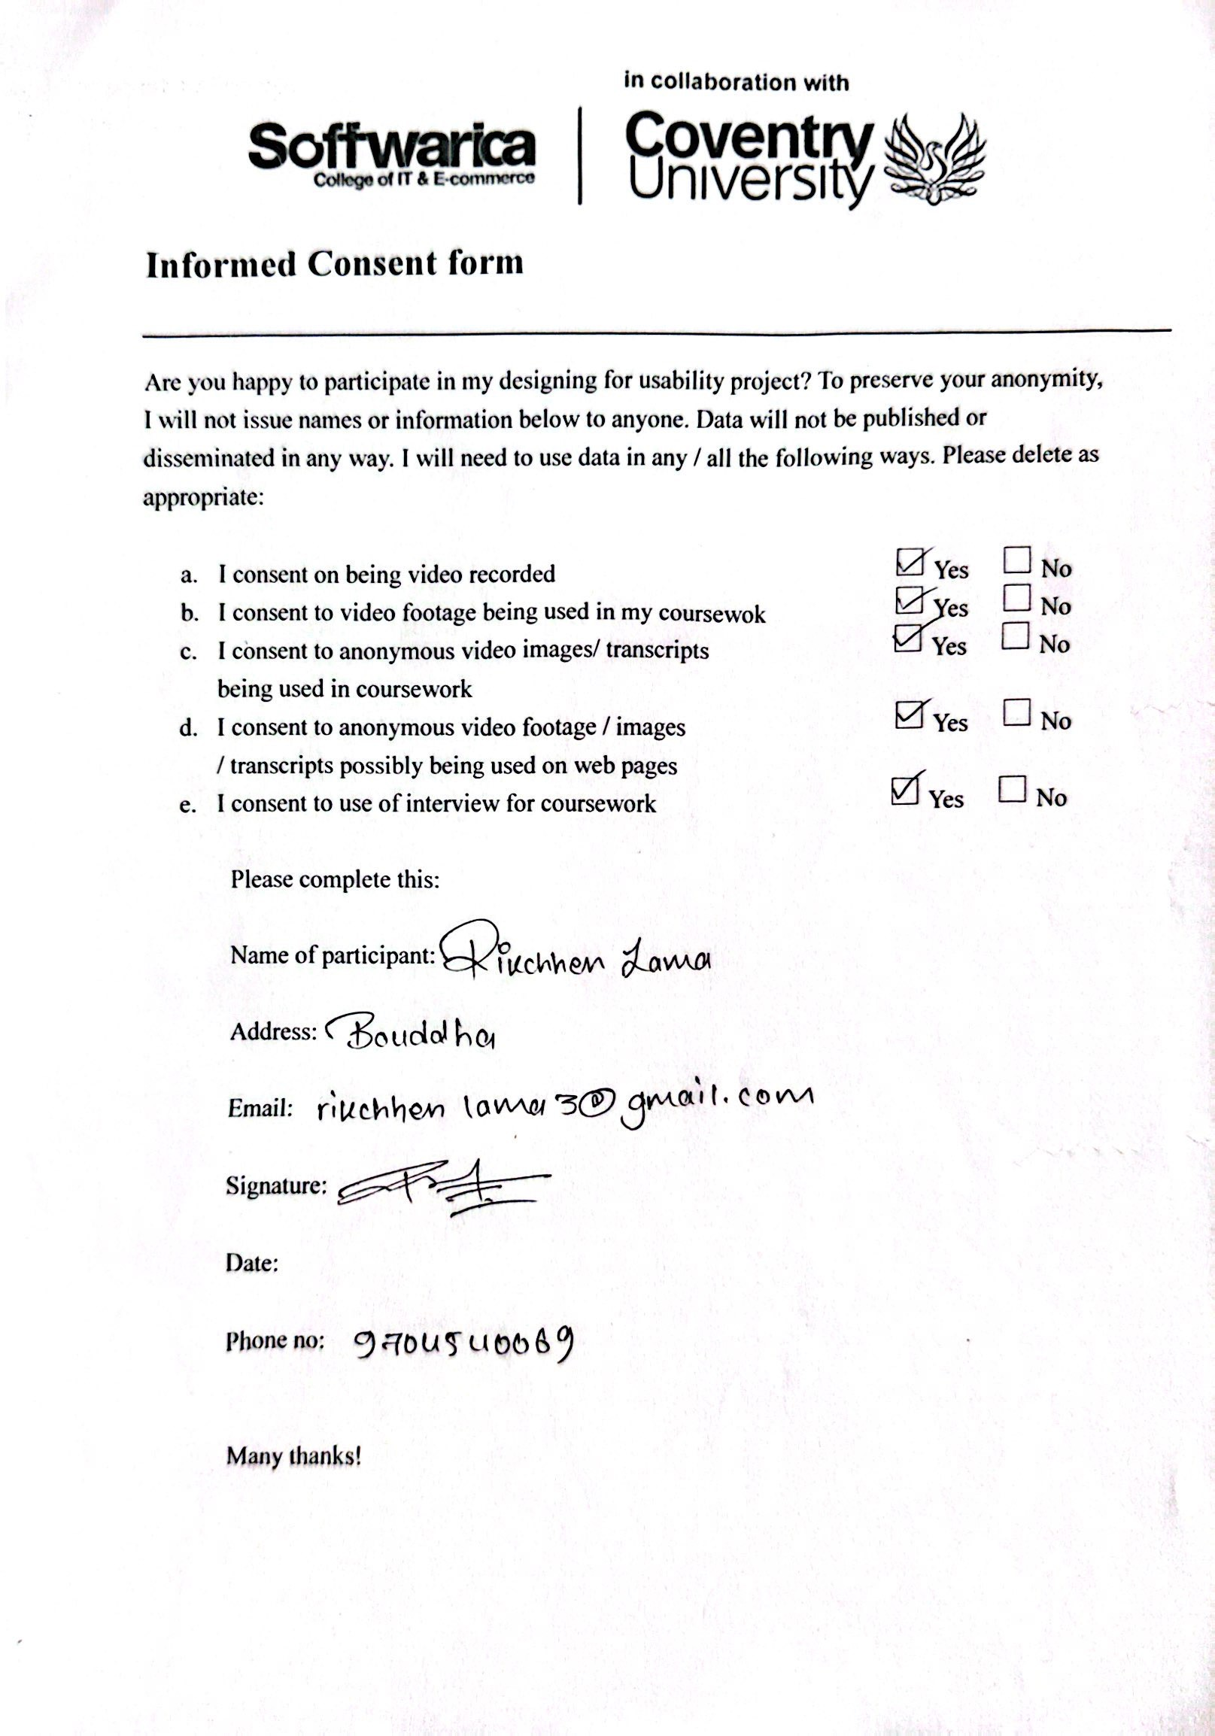

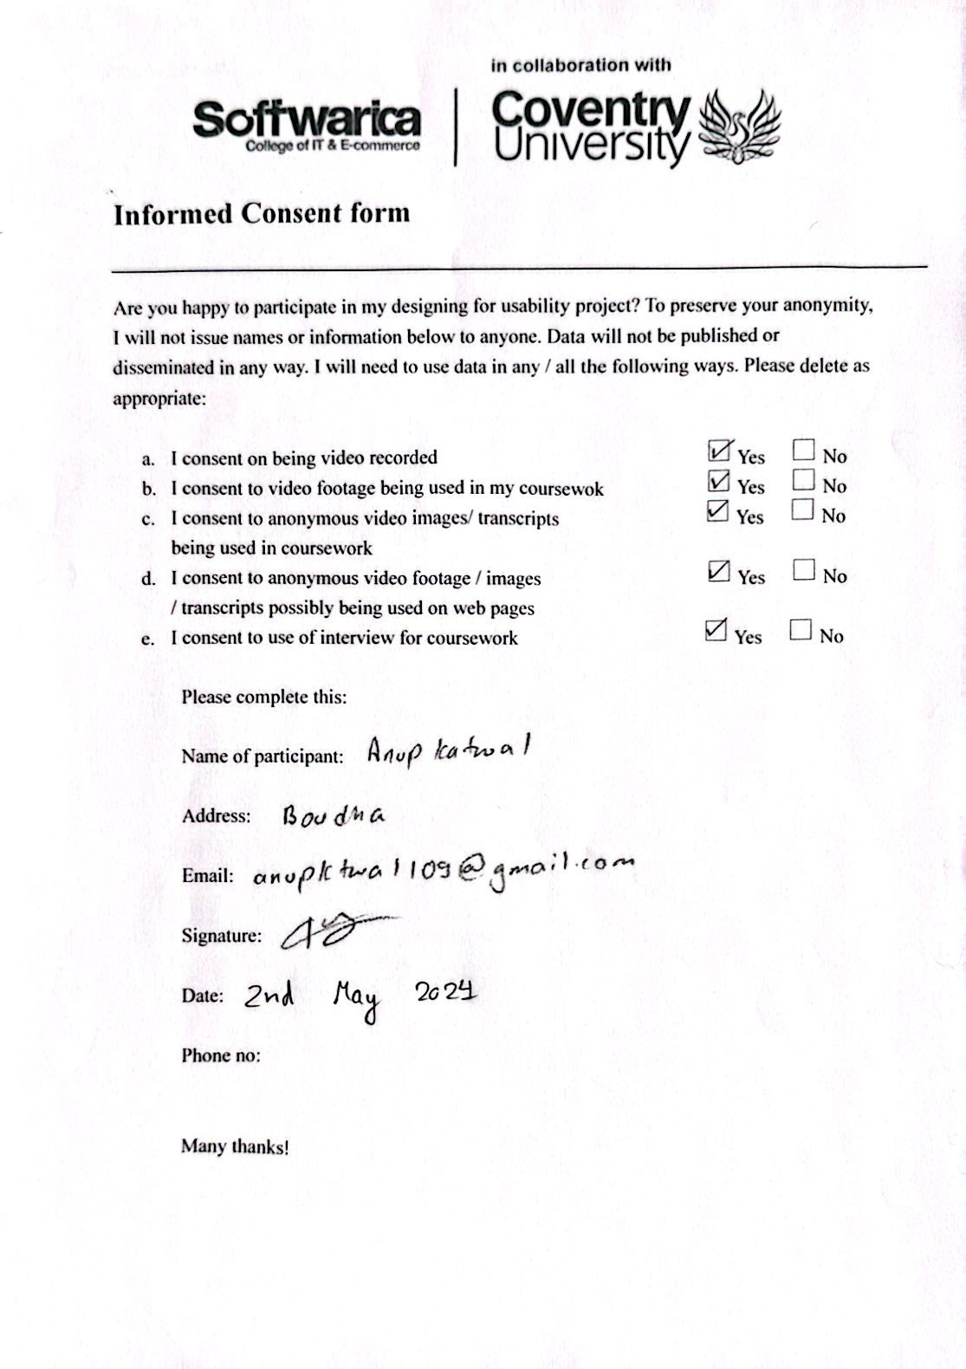

## **YouTube Link:**

1. **Low Fidelity: https://youtu.be/ubJqx9lhNNQ**
2. **High Fidelity:** https://youtu.be/YczWHsZ4BjU

## **User Survey:**

1. **Low Fidelity: https://forms.gle/o4iYvyEH5fSEA8CX8**
2. **High Fidelity: https://forms.gle/Hr23gax93ScvWNvX8**